2025 Bachelor's Graduation Thesis

Development of the CAM system for Incremental forming from 3D CAD data

Sophia University
Faculty of Science and Technology
Green Engineering and Applied Sciences Course
Precision Engineering Research Group

  - A2177802
  - Karter Wong
Table of Contents
Chapter 1: Introduction 3
1.1 Background information 3
1.2 Research objectives 3

• Abstract: Summary of objectives, methods, results, and significance.
• Chapter 1: Introduction
- 1.1 Background: CFRTP in manufacturing, challenges of low-volume production.
- 1.2 Research Objectives: Improving CAM system for incremental forming.
• Chapter 2: Background
- 2.1 Incremental Forming: Mechanics, history, types, applications.
- 2.2 NC Machine Tools: CNC evolution, G-code specifics.
- 2.3 CFRP: Properties, classifications, applications.
- 2.4 Literature Review: Prior work on incremental forming and CAM systems.
- 2.5 Previous Research: Analysis of prior thesis and research gap.
• Chapter 3: Experimental Tools
- 3.1 Machining Center: Specifications, setup.
- 3.2 CFRTP Material: Properties, preparation.
- 3.3 Oil Bath and Jig: Configuration, justification.
- 3.4 Python and CAM System: Software overview.
• Chapter 4: Toolpath Generation
- 4.1 CAM System Overview: Code structure, modules.
- 4.2 Toolpath Generation: Process, TSP logic, improvements.
- 4.3 Validation: NC viewer results, performance metrics.
• Chapter 5: Incremental Forming Experiment
- 5.1 Methodology: Parameters, procedures.
- 5.2 Results: Qualitative observations, quantitative measurements.
- 5.3 Analysis: Factors affecting forming, comparison with prior work.
• Chapter 6: Conclusion and Future Improvements
- 6.1 Summary of Findings: CAM system enhancements, forming outcomes.
- 6.2 Contributions: Impact on low-volume CFRTP production.
- 6.3 Future Work: Complex shapes, material variations, process optimization.
• Appendix: G-code samples, experimental data, additional figures.
• References: Complete bibliography with 15–20 sources.

Chapter 1: Introduction

1.1 Background information
With manufacturing moving towards more lightweight, durable, and renewable sources, materials like carbon fiber have been in the spotlight. While using molds and other manufacturing methods is more efficient for creating a large quantity of carbon fiber products, low-quantity, complex items are an issue because of their low quantity. The price to manufacture that item and the price for the consumer become higher.
As such, Dieless forming methods like 3D printing and incremental forming possess a unique opportunity to fill this need. Dieless forming methods allow manufacturers to produce low-quantity items at a lower cost, making those items cheaper for the consumer.

1.2 Research objectives
This paper aims to improve upon the Python code from a previous project so that a clean toolpath can be generated for incremental forming using CFRTP as the material.

Chapter 2: Background
2.1 Incremental forming technology
2.1.2 Development history
Incremental forming is a manufacturing method first proposed in Japan in the 1990s. This manufacturing method aims to make a dieless plastic processing method for low-volume, complex items. Incremental forming is a general term for processing plastics without dies and includes various techniques such as hot forming and local heating. In general, Incremental forming methods have five main characteristics:
- High degree of freedom in moldable shapes
- Not requiring a mold
- Forms thin shell shapes
- High forming limit for metal sheets
- Creating complex shapes that are in low demand
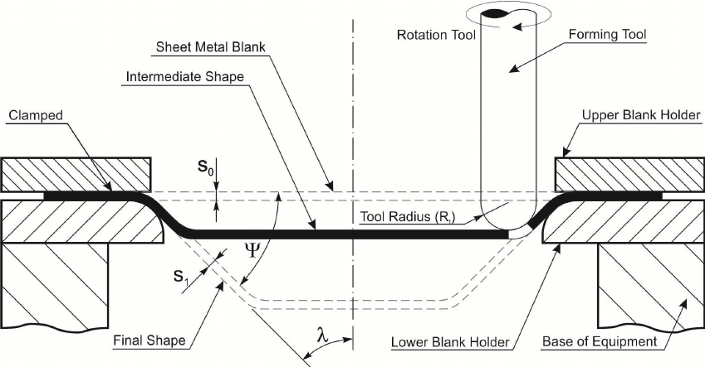
Figure 2.1: Incremental forming Diagram (Daleffe 2013)
2.1.3 Different types of incremental forming
There are two main types of incremental forming, dynamic and static. Incremental forming can be broadly classified into two main types: dynamic and static, based on the mechanism of material deformation. As shot peening exemplifies, dynamic incremental forming utilizes kinetic energy to shape the material, where small spherical media such as steel, glass, or ceramic shots are propelled at the material surface to induce deformation [1]. In contrast, static incremental forming involves slow, controlled material stretching, as seen in single-point incremental forming (SPIF), where a hemispherical tool progressively deforms the sheet into the desired shape [2]. While the dynamic/static terminology is not universally standardized, these categories align with the distinct process mechanics described in the literature, with shot peening representing kinetic-energy-based forming and SPIF embodying gradual deformation [2,4,5]. This classification provides a framework for understanding the diverse approaches within incremental forming, with static incremental forming being the focus of this research. Dynamic incremental forming uses kinetic energy to form the shape out of the material. An example is the shot peen method, where millimeter-sized shots made of materials like steel, glass, or ceramic are shot at the material you want to shape. Static incremental forming slowly stretches the material into the required shape. In this research paper, static incremental forming will be the method that we are using.

    - Uses of incremental forming
Incremental forming methods are helpful for various things, like prototyping, creating custom car parts, and testing new materials' characteristics. A real-world example of where incremental forming is used is in the LEXUS LC, EDGE produced by the Toyota Motor Corporation, as seen in the figure below, as shown in the red circle. The part of the car that uses incremental molding is the plastic bumper at the front of this car. Mention Ford, Nissan,


Figure 2.1: An example of Incremental forming on the Lexus LC, edge
2.2 NC machine tools​
    - Overview​
NC machines, or Numerical control machines, are machines that can be controlled with a set of numerical commands. The commands given to the machine can determine things like the position and speed of the tool. Programmed commands can execute a series of operations related to machines. This allows machines to do what was previously done manually by humans to be automated, shortening processing times, improving productivity, and reducing labor costs. Recently, a control method called CNC, a form of computer-based numerical control, has become common.
An NC program is a program for automatically operating NC machines. A program consists of blocks, which are the individual lines like the one below:
G01 X8 Y10 Z9;
Blocks are generally divided into two parts, the Function section (G01) and the coordinate section (X8 Y10 Z9;). The NC program can also be programmed to control the start and end of machining with specific notation specified in the table below (Table X). The function section (G01) will change depending on the function you want. The following are general descriptions for the different types of functions.
- G-Code
  - General Functions become preparatory functions in G-code and NC programs
- M-Code
  - Miscellaneous Functions are M-codes, auxiliary functions primarily used for commands other than movement.
- F-code
  - Control the F-code and feed speed from Feed Functions.
- S-Code
  - S-code controls the spindle rotation speed.
The following table shows the functions used in the G-code during this research.

Table 2.1: G-code functions
G Code | Positioning |  | G00
G Code | Linear interpolation |  | G01
G Code | Circular interpolation | Clockwise | G02
G Code | Helical interpolation | Counter clockwise | G03
G Code | Plane Selection | XY Plane | G17
G Code | Plane Selection | YZ Plane | G18
G Code | Plane Selection | ZX Plane | G19
G Code | Inch input |  | G20
G Code | mm input |  | G21
G Code | Local coordinate system settings |  | G52
G Code | Machine coordinate system selection |  | G53
G Code | Work coordinate system selection |  | G54-G59
G Code | Absolute coordinate command |  | G90
G Code | Relative coordinate command |  | G91
G Code | Work coordinate system settings. |  | G92
M Code | Spindle section |  | M03
M Code | Program end |  | M30
F Code | Feed Speed (mm/min) |  | F5
S Code | Rotation Speed (RPM) |  | S5

2.2.3 3D CAD
CAD (Computer Aided Design) is software for designing on a computer. CAD can be broadly divided into two types: 2D CAD and 3D CAD. With technological improvements, 3D CAD has been widely adopted in various industries. 3D CAD design software allows for easy planning of prototypes, so there are fewer errors in the production of the products. All test pieces and molds in this research paper were designed to be manufactured and tested using CAD.
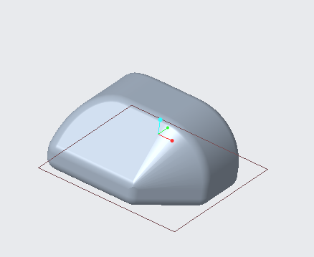
Figure 2.2: Example of something that was designed using CAD software
2.2.4 CAM
CAM (Computer Aided Manufacturing) creates machining programs for NC machine tools on a computer. Before CAM, workers had to input NC data directly into the machine tools, increasing the time spent on manufacturing and costs. As mentioned in the G-code section, CAM eliminated this process, speeding up manufacturing. In addition, because it is possible to verify the machining process visually through machining simulation, manufacturing can be even more efficient.

G90 ; (Absolute positioning)
G21 ; (Set units to millimeters)
G92 X0.0 Y0.0 Z0 ; (Set workplace origin)
F1000 ; (Set feedrate)
G01 X0.0 Y0.0 Z20 ; (Move to safe height)
Figure 2.3: Part of G-code

    - Tool path
A tool path is the path along which a machining tool moves. A tool path is created using the 3D coordinates of an STL file from CAD software to collect all the points or point cloud from the triangles of the STL file. From this, you sort the points, delete the duplicate points, generate a set of coordinates, and then add the necessary pieces to turn the coordinates into the NC program. The NC program can instruct the tool on the machining path. The toolpath was viewed using an NC viewer web browser to identify potential issues before manufacturing.
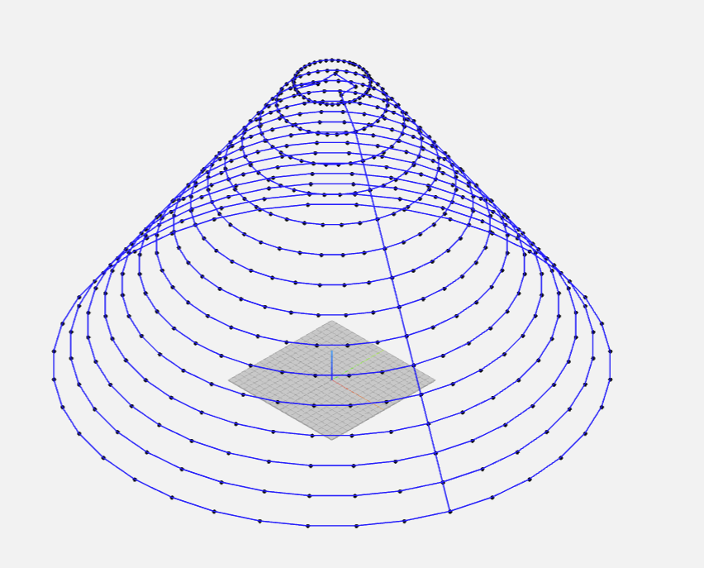
Figure 2.5: Tool path example
    - Python
Python is a widely used programming language known for its simplicity, readability, and versatility. It allows developers to condense programs in fewer lines of code than other languages like C++ or Java. In this research, Python was the programming language of choice for developing the CAM system used to produce the toolpath because it is easy to understand and apply. The code for the CAM system will be explained in a later section.

2.3 CFRP (Carbon Fiber Reinforced Plastic)
    - Overview
Carbon fiber reinforced plastics, or CFRP, is a general term for plastics reinforced with carbon fibers. The reinforcement allows CFRP to have high strength and rigidity compared to metal materials such as iron and aluminum, but also be significantly lighter. It also has excellent design and vibration absorption capabilities. As such, there has been an increase in the use of CFRP in many things like aircraft wings, car parts, sports equipment, and even medical uses.
2.3.2 Classification of CFRP
CFRP is classified into two types: Thermosetting CFRP (CFRTS: Carbon Fiber Reinforced Thermo Sets) and Thermoplastic CFRP (Carbon Fiber Reinforced Thermoplastic). CFRTSs are typically used for weight reduction in sports equipment, aircraft, etc. CFRTS has the following characteristics:
- High specific strength, high heat resistance
- Long molding time, high cost
- Not possible to recycle
CFRTP is also used in similar situations to CFRTS and has already been used in some automobile parts, which will be discussed later. CFRTP has the following characteristics:
- Specific strength and heat resistance are inferior to CFRTS
- Short molding time, low cost
- Partially recyclable
CFRP can also be divided into two other classifications depending on which direction the plastics in the CFRP are oriented. The two sections, continuous fiber and discontinuous fiber, have the following characteristics.
Continuous fiber CFRTP:
- Layered structure
- High specific strength
- Low press formability
Discontinuous fiber CFRTP
- Integrated structure, random orientation
- Specific strength is inferior to long fibers
- High press formability
2.3.3 CFRP application areas
As mentioned briefly in the previous section, CFRP can be used in various fields. In aircraft and car parts, CFRP is used in conjunction with other materials to make more efficient parts, such as airplane wings and car parts like bumpers. CFRP can also be used in the medical field in things like head braces for brain surgery to allow X-rays of the brain to be taken while keeping the patient's head stable, to a socket for prosthetics, taking advantage of its lightweight to reduce the overall weight of prosthetics.
2.3.4 CFRP sample used in this study
In this study, discontinuous fiber CFRTP is used because it has a short molding time, low cost, and recyclability.

2.4 Previous research A (Incremental forming of CFRTP under thermal bath conditions using oil bath and creating a CAM system using Python language.)

    - Overview
This previous thesis aims to create a CAM system using Python to perform incremental forming for discontinuous fiber-reinforced thermoplastics (CFRTP). An oil bath heats the CFRTP to enable incremental forming without molds. The previous researcher developed a custom CAM system in Python to generate G-code tool paths from CAD models, targeting low-volume, high-mix production needs. The Python code can be seen in the next section.
The study addresses challenges with traditional manufacturing, such as high mold costs and limited flexibility, especially in forming thin shell components. It introduces a cost-effective alternative that combines material heating via an oil bath with open-source digital toolpath generation.

    - CAM and CAD system
The CAM system achieved three goals: to read STL files from Creo Parametric 4.0, extract 3D point clouds of target shapes, and create a tool path in G-code. The code uses Python libraries, as seen in Figure X, to make a point cloud from the STL file. It converts the clouds into layers by Z-height and connects the points in each layer by the minimum Euclidean distance. Finally, it takes the coordinates and adds the proper syntax to be used by the CNC machines.
The Shape created in Creo was a truncated cone with varying dimensions. The radius of the shape ranges from 20, 30, and 40 mm, and similarly, the wall angle is 30°, 40°, and 50°, and the pitch or resolution of the STL is 1. The dimensions were selected to match the working area and limitations of the experimental setup. The shape was chosen because it is good for proof of concept, especially for plastic deformation layering.

import pyvista as pv
import csv
import pandas as pd
import numpy as np

mesh = pv.read('test_piece_3.stl') # Load the STL file and name it "mesh"
points = mesh. points # Get the point cloud from "mesh"
with open('dots.csv', 'w') as f: # Create a new CSV file
writer = csv.writer(f) # Set to write mode
writer.writerows(points) # Write the point cloud

df = pd.read_csv('dots.csv') # Open the CSV file with pandas
df = df.dropna() # Remove blank rows
df = df.set_axis(['x', 'y', 'z'], axis='columns') # Label columns as x, y, z (with space for row numbers)
maxi = df['z'].max()
mini = df['z'].min()
df = df[df['z'] > mini + 0.01] # Remove the bottom plane
df.to_csv('dots.csv') # Overwrite the CSV file
df = pd.read_csv('dots.csv') # Re-open the CSV file with pandas
ll = [0, 0, 0] # Specify that this is a 3-dimensional numeric array
pp = [0, 0, 200] # Set a hypothetical initial tool position

Figure 2.6: Initial setup

while len(df) > 0:
s = df['z'].max() # Find the maximum value along the z-axis
df_z = df[df['z'] == s]
df_z.to_csv('layer.csv')
df_z = pd.read_csv('layer.csv')
df_z = df_z.drop(df_z.columns[[0, 1]], axis=1)
df_z.to_csv('layer.csv')
p = df_z['z'].idxmax() # Maximum value on the z-axis, starting from this point for processing
l = np.loadtxt('layer.csv', delimiter=',', dtype='float64', skiprows=1, usecols=[1, 2, 3]) # Convert from CSV to ndarray
n = len(df_z) # Get total number in df
c = 0
if n == 1:
pp = l
ltp = [0, 0, 0] # Tool path design order
if n > 1:
while n > 0:
j = 0
ld = []
if c == 3:
l = np.vstack([l, llk])
n = n + 1
while j < n:
ld.append(np.linalg.norm(pp - l[j])) # Calculate and list distances from p
j += 1
k = ld.index(min(ld)) # Index of the smallest value in ld
lk = l[k] # Array at the index of the smallest value in l
ltp = np.vstack([ltp, lk]) # Add lk vertically as an array to ltp
if c == 0:
llk = lk
ld.pop(k) # Delete the k-th element in ld
l = np.delete(l, k, 0) # Delete the k-th row in l
n -= 1 # Reduce n by one
pp = lk # Set next p as the current k
c += 1
ltp = np.delete(ltp, 0, 0)
ll = np.vstack([ll, ltp])
else:
ltp = np.delete(ltp, 0, 0)
ll = np.vstack([ll, l]) #Transform df to remaining layers
df=df[df['z']<s]
ll = np.round(ll, 3) # Round to 3 significant digits

With open('toolpath.csv', 'w') as f:
writer = csv.writer(f)
writer.writerows(ll) # Save ll to CSV
Figure 2.7: Toolpath generation

df_ltp = pd.read_csv('toolpath.csv')
df_ltp = df_ltp.set_axis(['x', 'y', 'z'], axis='columns')
df_ltp.to_csv('toolpath.csv') # Convert to G-code from here

l = np.loadtxt('toolpath.csv', delimiter=',', dtype='float64', skiprows=1, usecols=[1, 2, 3])
lx = l[:, 0] # 0th column of l
ly = l[:, 1] # 1st column of l
lz = l[:, 2] # 2nd column of l

map1 = map(str, lx)
lx = list(map1) # Change data type to string
map2 = map(str, ly)
ly = list(map2) # Change data type to string
map3 = map(str, lz)
lz = list(map3) # Change data type to string

n = len(df_ltp)
for i in range(n):
lx[i] = ('X' + lx[i]) # Add "X" prefix to n coordinates
for i in range(n):
ly[i] = ('Y' + ly[i]) # Add "Y" prefix to n coordinates
for i in range(n):
lz[i] = ('Z' + lz[i]) # Add "Z" prefix to n coordinates

df_gchord = pd.DataFrame(data={'G': 'G01', 'x': lx, 'y': ly, 'z': lz, 'EOB': ';'})
glist = df_gchord.values

outf = open("Gchord.csv", 'w', newline='')
writer = csv.writer(outf)
writer.writerows(glist)
outf.close()
df_g = pd.read_csv('Gchord.csv')

df_g.to_csv('Gchord.txt', index=False, sep=" ")

Figure 2.8: G-code conversion and exporting the G-code to a text file.

2.4.3 Experimental equipment:
The following equipment was used in the previous research. Most of the materials used in the previous experiment will be used in the research and explained in more detail later.
- CFRTP sheet (PA6 matrix, 20 wt% carbon fiber)
  - Size: 110 mm × 110 mm × 1 mm
  - Dried at 120°C for 24 hours using an ETTAS oven to prevent moisture-induced degradation.
- Heating Equipment:
  - Oil bath: T-22H model (Thomas Scientific)
    - Temperature range: up to 200°C
    - Precision: ±0.2°C (PID controlled)
    - Stirring method: jet circulation
- Oil used: KF968 (Shin-Etsu)
  - Non-volatile, stable to 250°C, fire-resistant
- Forming System:
  - CNC Machine: Sodick MC430L
    - Travel: X 420 / Y 350 / Z 200 mm
    - Feed: up to 36 m/min
  - Tool (Mandrel): SUS304, 5 mm dia, 2.5 mm radius tip, 60 mm long
  - Custom jig submerged in the oil bath with secure clamping and easy detachment for safety and repeatability.
- 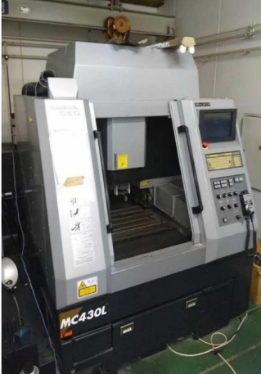
- Figure 2.4: Appearance of M C430L

2.4.4 Results
The experiments revealed that several factors contributed to successful forming: the temperature of the material, the tool rotation, the wall angle, and the radius variations. The temperature that achieved the best results ranged from 180–200°C (453–473 K), and the lowest temperature that had a successful forming was 323 K. Below 160°C (433 K), the material failed to deform properly, often leading to cracks.
It was also found that the tool's rotation at 1000 rpm played a big role in increasing depth and smoother walls. Without rotation, the surfaces' finishes were poor and tended to have uneven wall thickness.
The angle of the wall had some influence on the formation. The best wall angles tended to be 30° and 40°. At these angles, there was smooth forming and minimal spring back, and when it was closer to 40°, some deformations were observed. Anything that was 50° or greater had risks of cracks and breakage.
The radius of the shape also played a big part in forming; it was found that the smaller the radius (20 mm), the deeper the forming depth, but a much higher wall stress, and 40 mm produced less depth but more uniform wall strength.
The maximum and minimum criteria for a successful formation were the following:
  - Maximum: 14.9 mm at 200°C, 20 mm radius, 40° wall angle.
  - Minimum: 3.6 mm at 160°C, 50° wall angle, without rotation.
2.4.5 Conclusions:
The researcher successfully created the Python CAM System and generated tool paths from STL data. This process also smoothed incremental forming, improved the flexibility of the existing toolpath generation methods, and allowed the support of arbitrary shapes, ultimately creating a system that could be used in production environments.
The CAM system created in previous research A was used as a starting point for the CAM system that will be shown later. There are many similar aspects, but also some improvements from what is shown here.
Chapter 3: Experimental tools
  - Machining center
The tool path used in incremental forming is the same as the G code used by normal machine tools. Therefore, incremental forming can be done by customizing a machining center without purchasing a dedicated machine. In this study, a general-purpose machining center, a precision linear nano machining center (MC430L) from Sodick Co., Ltd, was used. By attaching an incremental forming device and an oil bath to this machining center, incremental forming became possible. The figure below shows what the machine center Figure 3.1 shows the appearance of the machining center..
Figure 3.1: Appearance of MC430L

  - Python
As mentioned in a previous section, Python is an open-source programming language known for its simplicity, readability, and versatility. It's widely used in data science, web development, automation, machine learning, and computing. The easy accessibility, simple syntax, and large number of libraries that help with specific tasks are reasons why it will be used in this research.
As mentioned before, Python is used to build a CAM system that takes STL data and generates G-code for CNC machining.

  - Discontinuous CFRTP
As mentioned earlier in this paper, this study will use discontinuous CFRTP as the test material. The integrated structure, random orientation of the fibers, and high press formability are all reasons for the use of discontinuous CFRTP. The CFRTP sheets used are PA6 matrix, 20 wt% carbon fiber. The dimensions will be Size: 110 mm × 110 mm × 1 mm, and it will be dried at 120°C for 24 hours using a hot air drying furnace oven to prevent moisture-induced degradation during the incremental forming.
  - Oil bath
The oil bath that will be used in this experiment is the oil bath that was used in the previous experiment, the T-22H model (Thomas Scientific). The oil bath can reach temperatures up to 200°C, has a precision of ±0.2°C, and uses jet circulation to move the oil around, ensuring that the heat of the oil is uniform.

  - Type of oil
The silicone oil used is Shin-Etsu Chemical's K F968. Due to the characteristics of the sample, the liquid used in the oil bath must be resistant to temperatures between 323K and 473 K. This is also necessary to ensure safety during experiments.
- High temperature resistance
- Low thermal degradation (anti-spontaneous combustion)
- Low volatility
- This oil is used to satisfy the above points. The appearance is shown in Figure 3.2 below.


Figure 3.2: Shin-Etsu Chemical KF968 oil that is used.

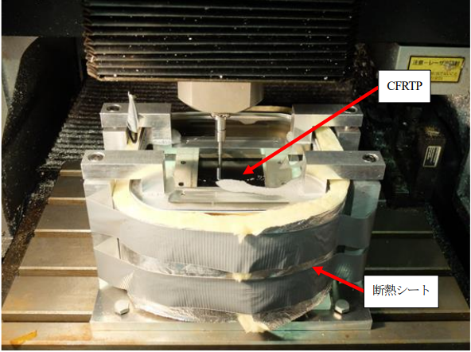

Figure 3.3: Incremental stretch forming with hot water assistance in oil bath (2017 )

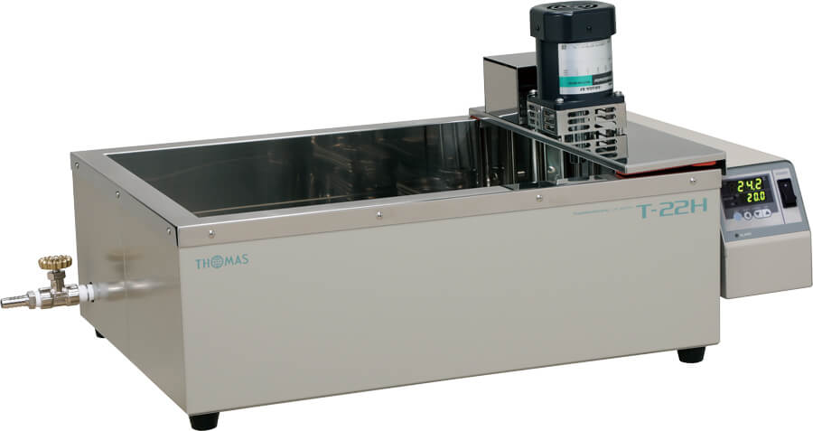
Figure 3.4: Appearance of T-22H

  - Forming tool
This study used a 5 mm diameter rod with a 2.5 mm rounded tip as a tool. The mandrel diameter was the same as that in the previous study. In addition, due to the offset of the incremental forming device attached to the machining center, the rod's length was set to 60 mm. The material was SUS304.
Mega Micro type S Chuck
Ød : | 0.45 - 6.05
ØD: | 14 mm
L: | 45
L1: | 32
G: | -
H1: | 28
H2: | 31

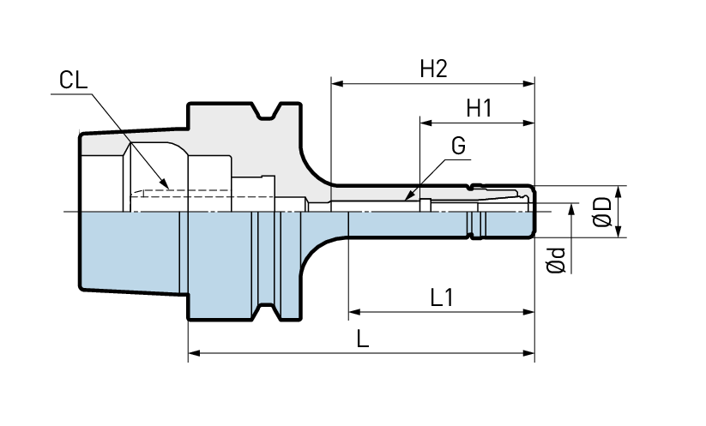
Figure x: Mega micro type s chuck without the tool

  - Master mold
A preliminary test using a 3D-printed mold proved that the shape could be manufactured using incremental forming. This is an important step, but it is not the focus of this paper and will be briefly mentioned in a later chapter.
  - CFRTP dryer
When the base material resin is heated, deterioration of the resin is expected at high temperatures. It is known that the presence of water in the material significantly affects deterioration. PA6 resin, the base material used in this study, is also hygroscopic, so the CFRTP must be thoroughly dried before processing to remove the chance of deterioration. The hot air drying furnace, MOV-450S from AS ONE Corporation was used to dry the CFRTP to achieve this. The ETTAS is shown in the figure below. The ETTAS can be set from room temperature to about 240 K, and the size of the oil heating area is 445 mm x 440 mm x 650 mm.
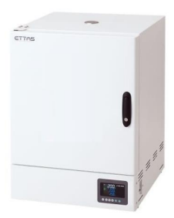
Figure 3.5: Appearance of the constant temperature dryer
  - Jig Dimensions
A jig is required to hold the CFRTP and oil in place while forming. The upper frame of the jig is removable and secures the CFRTP, improving work efficiency and safety. Figure X shows the dimensions and what the jig looks like.
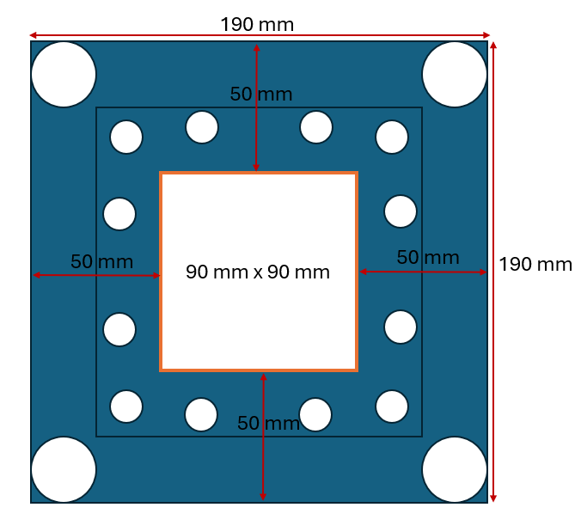
Figure 3.6: Jig dimensions

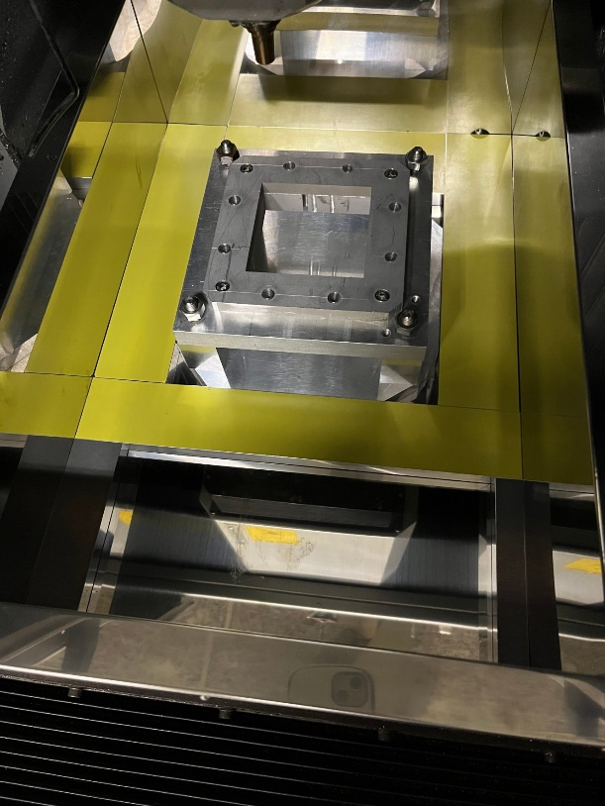
Figure 3.7: Jig arrangement (actual)
Chapter 4: Toolpath generation
  - Breakdown of the program
Python is used to develop the CAM system for the toolpath generation because it was mentioned in the previous chapter. The CAM system below is based on the earlier research’s CAM system; however, it was adjusted for more complex shapes rather than just a truncated cone. The following code is divided into four simple sections, which will be explained in the following sections.
The general flow of the program goes like this. Import the STL data from the design software-> setup of the variables, libraries, and tool path logic -> toolpath generation and g-code conversion-> compiling and finishing touches, and can be shown in the figure below.

Figure 4.1: General outline of CAM program

Figure 4.2: Variables and library setup
Figure 4.3: Setting up logic for the tool path generation
Figure 4.4: Tool path generation
Figure 4.5: Initial machining and termination code with exporting the toolpath to a text file.

  - Variables
A few variables are required for an accurate depiction and overall consistency of the tool path. The most important ones are mesh subdivisions, layer spacing, and tolerance. Mesh subdivisions divide each layer into parts so that more points are added to the tool path, giving a smoother tool path and making it less likely to have any problems. The layer spacing variable ensures that all the layers in the toolpath are the same distance apart. For example, layer one and layer two will have a 0.2 distance, and layer 10 and layer 11. The tolerance variable for the toolpath is a redundant measure to ensure that the toolpath does not have any issues when generating a circular shape vs. a shape with edges.

  - Modules
The “modules” or toolpath logic are groups of code that smooth out the processing of the tool path. If they were to be added to the toolpath generation logic seen in Figure X, generating a toolpath would take significantly longer. Things like TSP, which will be explained in the next section, and Clockwise processing are just some of the modules in the code.

  - TSP (Traveling Salesperson)
The most important module of the CAM system is the TSP logic. While the code in Figure 4.4 is also crucial, the TSP logic ensures that the tool path will not double back on itself and create problems. The TSP logic does this by calculating the distances between the current point it is at and the points on the layer. After it does this, it will move the tool to the shortest distance point and repeat the process until all the points are reached. Something like the TSP logic was present in the previous researcher's research; however, it was adjusted so that other modules could be used to optimize the code further.

  - Processing loop overview
The process of toolpath generation involves several simple steps. First, the logic creates a variable so the entire toolpath can be stored and later saved to a text file. Next, the toolpath generation will identify the highest Z coordinate or the highest layer of the figure, then eliminate any layers that have fewer than 3 points, as the module Convexhull, a module that selects the outermost points of a layer, cannot process layers that have fewer than 3 points. Then the Convexhull module selects the outermost points of the layer, and then the circular and noncircular processing modules are used to determine which type of processing to use. This redundant measure is here to ensure that nothing goes wrong with the TSP logic. The final part of the toolpath generation is moving to the next layer. The toolpath generation looks for the closest point on the next layer and saves that so the tool can return to that point later when it needs to move to the next layer. This creates a general area where the toolpath generation will always move to the next layer, cleaning up the toolpath visually. This will then repeat the number of layers in the STL file.

  - Reverse offset
  - General G-code addons
For the last section of the code, the general processing settings like spindle speed, setting the machine to absolute positioning, and setting the workplace origin are added to the beginning and end of the code so that the toolpath is ready to be put into the CNC machine right after the program is finished generating the G-code. These are found in the header and footer sections of the code and were explained in an earlier section.
The final part of the code, shown in Figure 4.5, is to save the toolpath generated into a text file that can be directly input into the CNC machine.

  - Summary of changes and importance of them

  - NC viewer confirmation
After the CAM system generates the toolpath, the NC viewer, an online website that visualizes the G-code, is used to ensure it is error-free. The NC viewer also simulates what will happen in the incremental forming process and can be edited as needed.
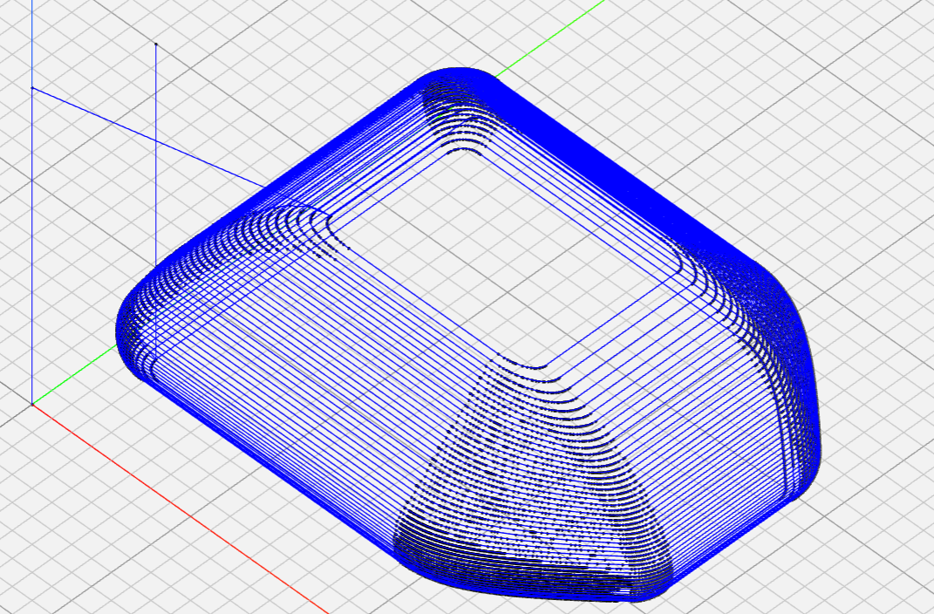
Figure 4.4. NC viewer confirmation of the toolpath.

Chapter 5: Incremental forming Experiment
  - Plastic feasibility study of manufacturing
  - CFRTP testing
P A6 ( discontinuous fiber FRTP), a resin with poor moldability, is heated to near its melting point using oil, and the resin is softened and then molded incrementally, assisting in the molding process. [1 8 ]

Chapter 6: Conclusion and Future Improvements

Appendix

Chapter 7: References
[1] Bagherifard, S., Ghelichi, R., & Guagliano, M. (2018). Shot peening: A review of the process and its applications. Journal of Materials Processing Technology, 258, 188–202. https://doi.org/10.1016/j.jmatprotec.2018.03.025

[2] Duflou, J. R., Habraken, A. M., Cao, J., Malhotra, R., Bambach, M., Adams, D., ... & Merklein, M. (2018). Single point incremental forming: An assessment of the progress and technology trends from 2005 to 2015. Journal of Manufacturing Processes, 28(3), 373–391. https://doi.org/10.1016/j.jmapro.2017.04.015

[3] Guttag, J. V. (2021). Introduction to computation and programming using Python (3rd ed.). The MIT Press.

[4] Ikari, T., & Tanaka, H. (n.d.). Feasibility study of laser-assisted incremental forming for carbon fiber reinforced thermoplastic based on 3D CAD data.

[5] Ikari, T., & Tanaka, H. (n.d.). Feasibility study of single point incremental forming for discontinuous fiber CFRP using oil bath heating

[6] Mitsumori, T. (n.d.). Taiga Mitsumori’s research paper.

[7] Sharma, V., Sharma, V., & Shukla, O. J. (2014). Principles and practices of CAD/CAM. Katson Books.

[8] Shovic, J. C., & Simpson, A. (2021). Python all-in-one for dummies. Wiley.

[9] Smid, P. (2006). CNC programming technologique. Industrial Press.

[10] Daleffe, Anderson & Schaeffer, Lirio & Fritzen, Daniel & Castelan, Jovani. (2013). Analysis of the Incremental Forming of Titanium F67 Grade 2 Sheet. Key Engineering Materials. 554-557. 195-203. 10.4028/www.scientific.net/KEM.554-557.195.

